**Working with Standard Agents:**

**Req: Send email notification for every 30 sec:**

**Open Existing Activity ( AdvEmail Act)**

**Open Activity &Use Saveas Option**

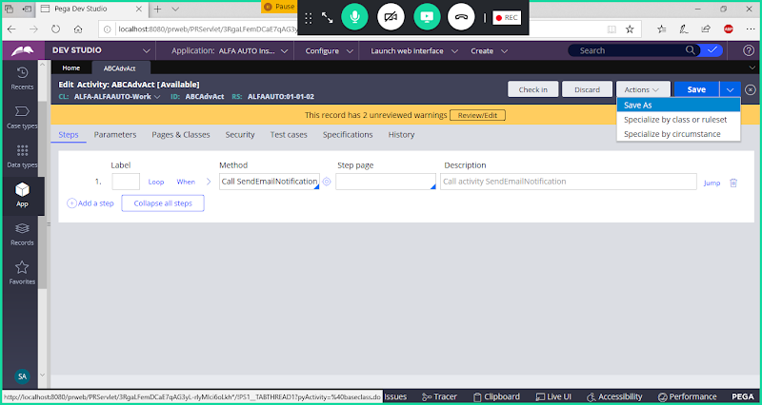

**Change Label:**

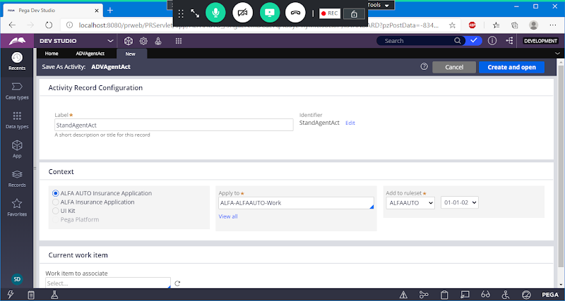

**Open**

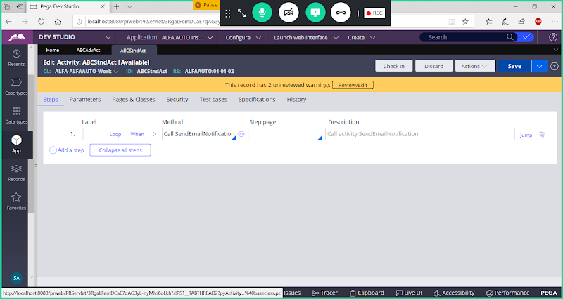

**Save Activity**

**Open Existing Agents Rule:**

**Add New Agent**

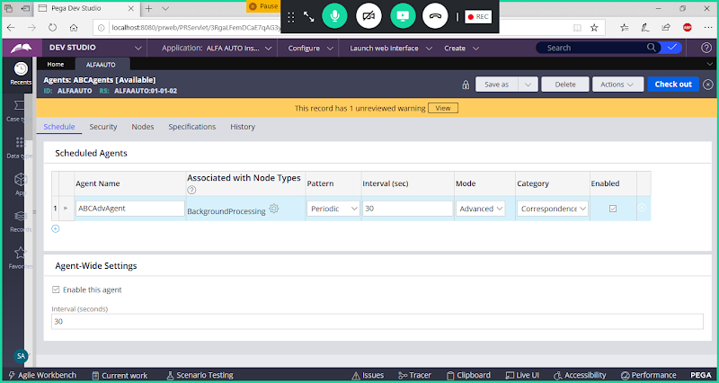

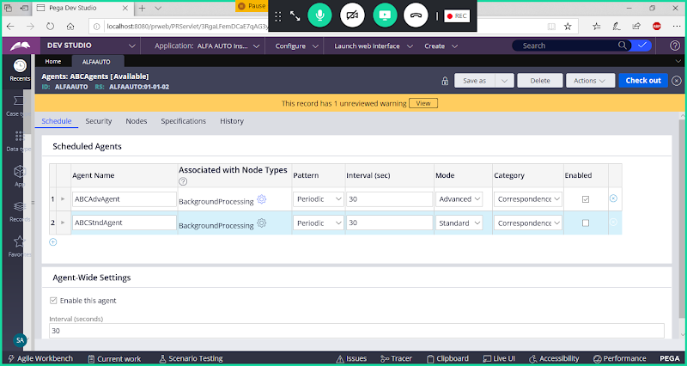

**Enable Checkbox to start the Agent**

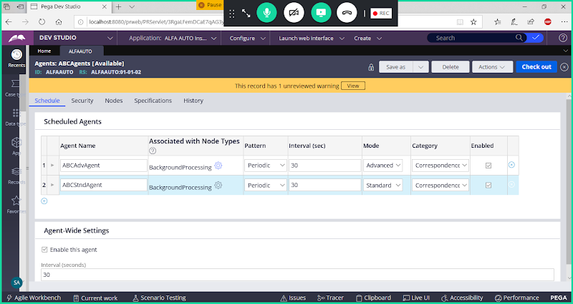

**Add Class Name & Activity Name**

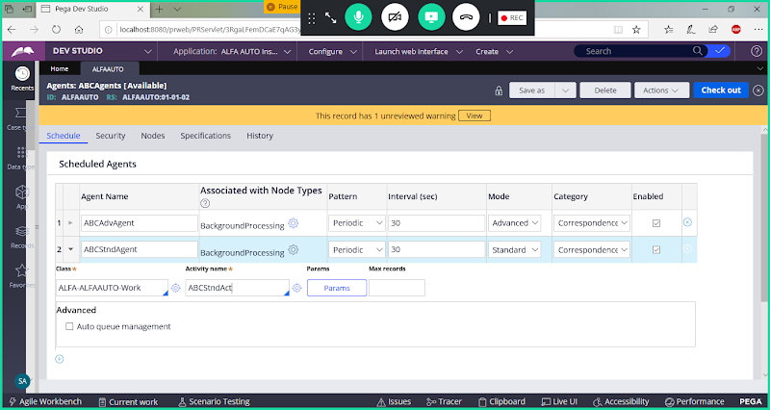

**Enable Auto Queue Management**

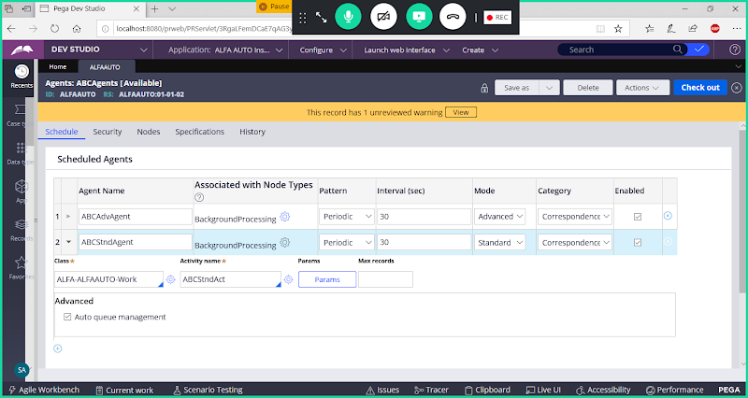

**Save Agents Rule**

**After 5 Minutes  Log off & Log in & Refresh Agent. Node Id will be Created.**

**Open Agents Schedule Rule from Records Explorer:( Records->Sysadmin-> Agent Schedule)**

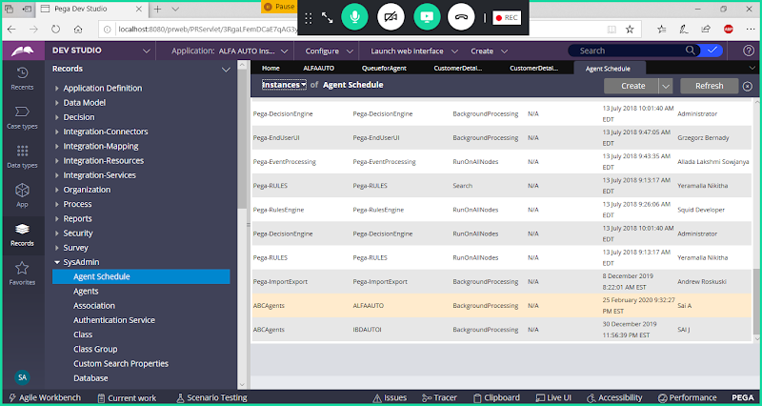

**Open Agents Schedule:**

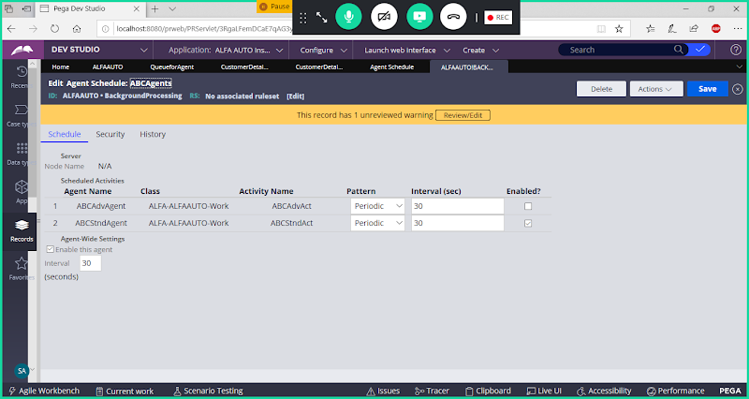

**======**

**Cont..to Standard Agents**

**But it will not send notification periodically for every 30 sec**

**Once standard agent is added we need to put queue items to Queue Table;**

**Queue Table: pr_sys_queues**

**How to add queue items to Queue Table**

**Predefined Activity: QueueforAgent**

**Create Activity:**

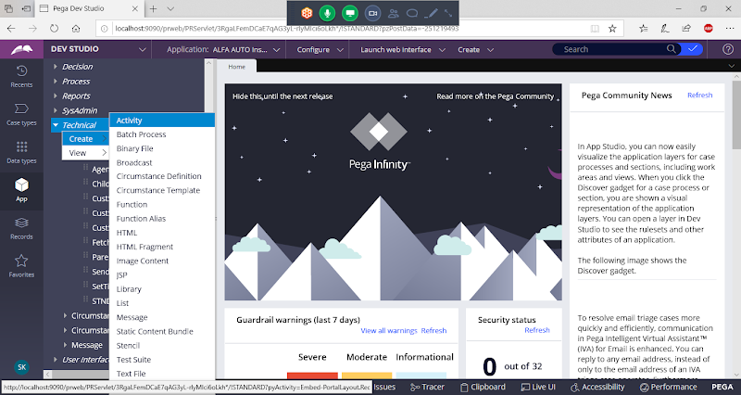

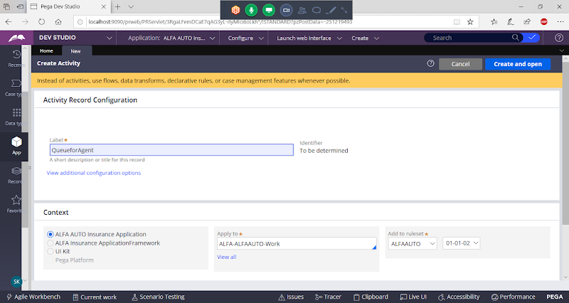

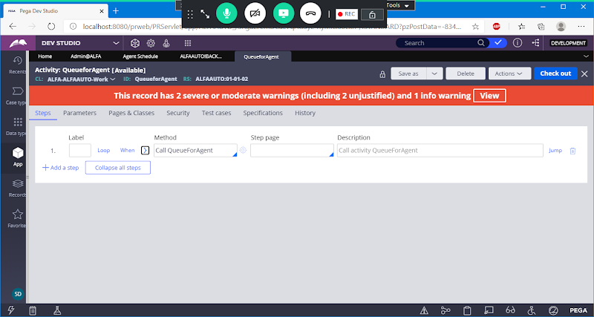

**Fill Parameters**

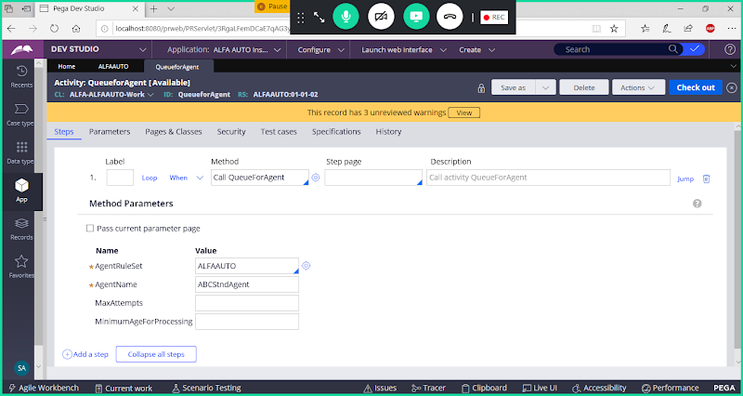

**Save Activity**

**Now Call Activity in Customer Details Flowaction -> Actions->PostProcessing**

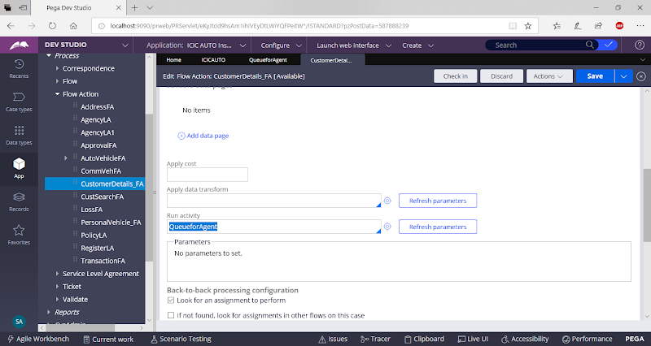

**Run Customer Flow. Now Queue Item will be added to table.**

**=========**

**Open Server- >pr_sys_queues**

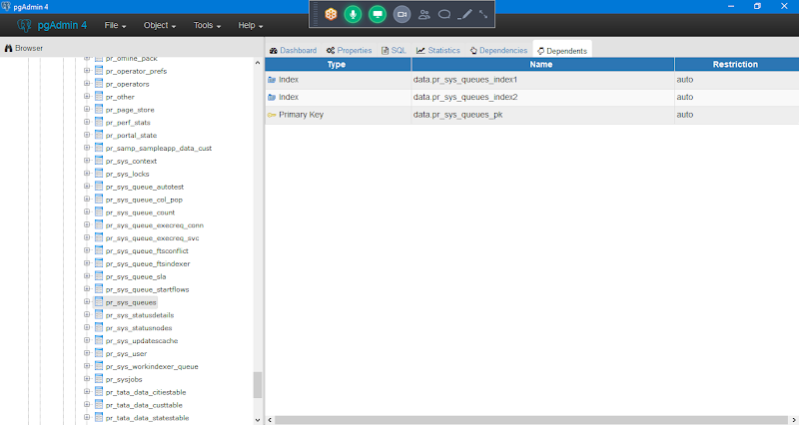

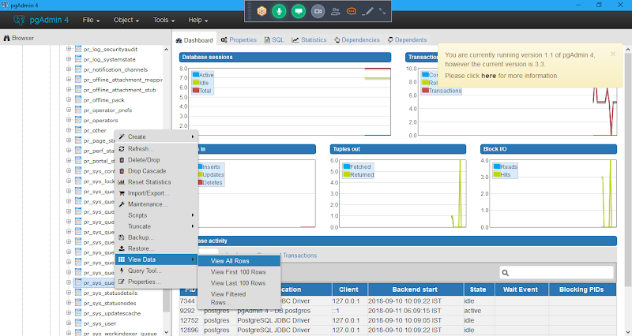

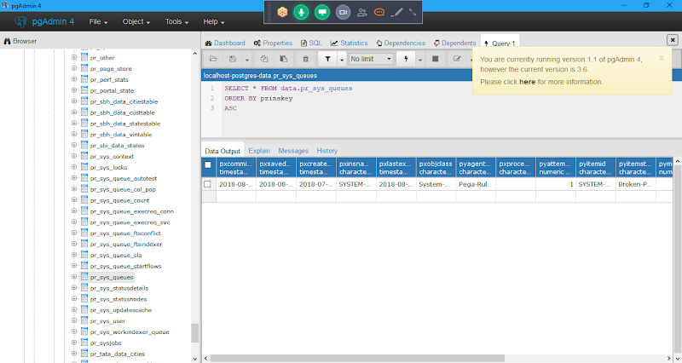

**In queue table you can check the status as  Scheduled->Now Processing ->Success/Broken Process(Fail)**

**If Success Means- > It will read Agent Activity & Remove the Queue Item from the Queue Table.**

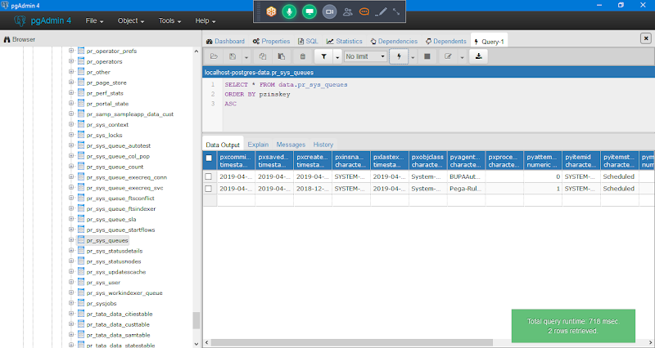

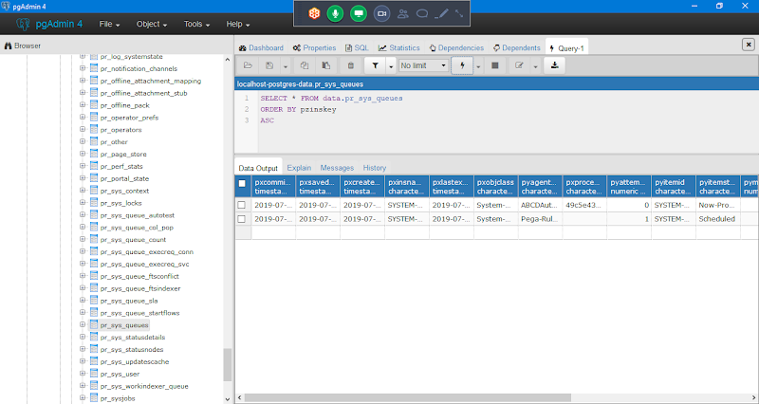

**If Any issue with Activity Steps Means -> It will show the status as Broken Process**

**- Only if Queue Items are added to table, then only it will execute agent activity.**

**- After Processing ( After reading Activity ) is done queue item will be deleted from the queue table & It will send email notification**

**What Happens with Broken Process items & How to ReQueue them:**

**Open Activity & Give wrong password.**

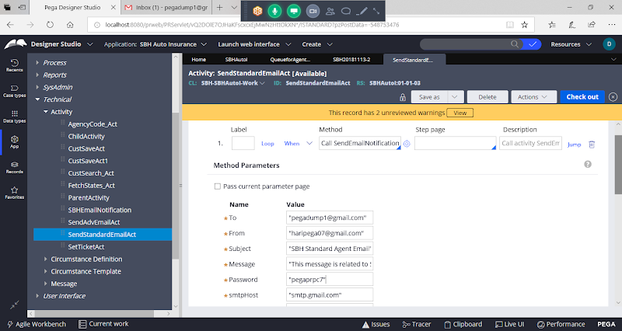

**Save Activity**

**Run Flow  & Open Server & Check in Queue Table.**

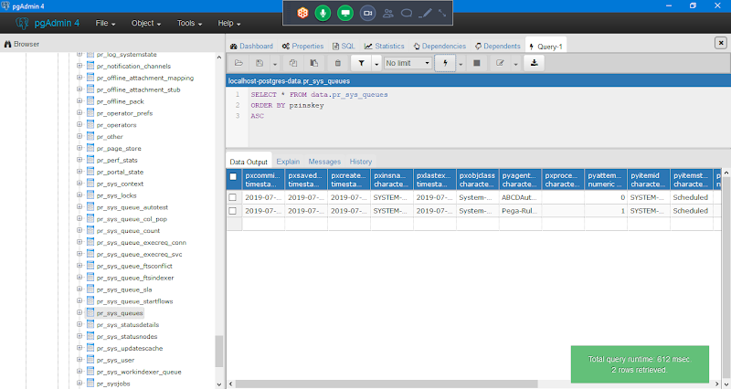

**Again Refresh**

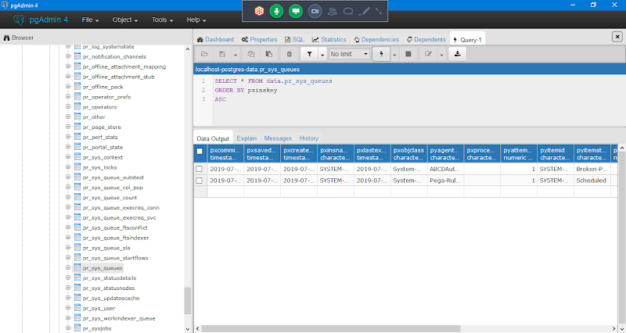

**In Queue Table work items is in Broken Process Status. ( If something failed then it will be in Broken Process Status)**

**======**

**Agent Schedule:**

* **Agent is an instance of Rule-Agent-Queue**
* **Agent schedule is an instance of Data-Agent-Queue**
* **When agents are created Agents schedule will be automatically created.**

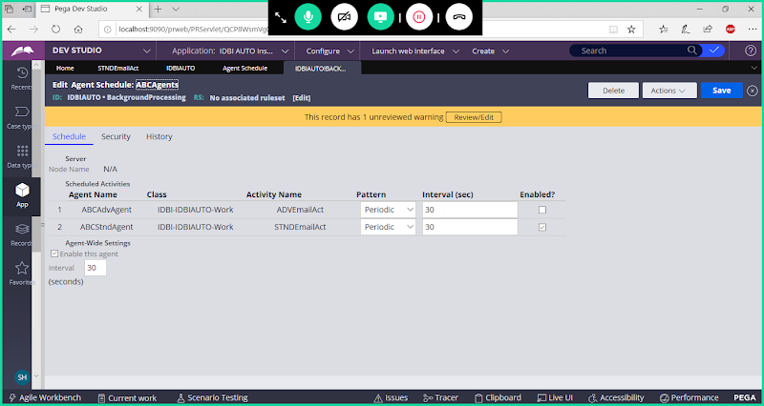

**In agent schedule we can edit Interval & Enable/Disable the agent.**

**- Master Agent( System Pulse) will wakeup agents as per their Agents Schedule Rule**

**==============**

**Enable Auto Queue Management( Standard Agents)**

**Save Agents & wait till the node id gets generated.**

**Diff b.w Advanced & Standard Agent:**

**Ex:  Insurance Policies  ( Pending- Activation)**

**Advanced Agent:  100 Policies**

**In Advanced agents if anything failed at 30th Record, it will stop there & it will not process remaining Records.**

**Standard Agent:  100 Records**

**In Standard agents if anything failed at 30th Record, it will not stop there & it will process remaining Records.**

**==========**

**Diff b/w Standard  & Advanced Agents:**

**Standard Agents:**

* **Execute activity n no of times. ( N is no of queue items)**
* **Transactional Processing**
* **We Can run in Multi Node Environment, i.e standard agents can be configured to run on multiple nodes**
* **We need to define Auto Queue Management**
* **When queue items are there, Standard agent will execute the Agent Activity else it will not execute activity & goes to sleep.**

**Advanced Agents:**

* **Executes activity only once per wakeup ( Based on interval)**
* **Non Transactional Processing**
* **Preferred to run on single node**
* **No Auto Queue Management in Advanced Agents, because Advanced Agents are configured on Single Node**
* **When wakeup executes activity with out bothering about Agent Queue Items**

**Agent Modes/Agent Types:**

* **Legacy: it is Deprecated from 5.4 Version**
* **Advanced:**
* **Standard:**

**AQM: Auto Queue Management**

**This is responsible for instructing your agents whether to execute associated agent activity or not.**

**Queue Table: Status**

* **Scheduled: This is Initial status, when queue is inserted to table this status will start**
* **Now Processing: Means queue is picked by the agent & is being processed**
* **Broken- Process: When queue item fails in its processing then status will be broken process**
* **If Queue item is success, then it will be removed from the Queue table.**
* **In queue table you can check the status as  Scheduled->Now Processing ->  Success/Broken Process**
* **Only if Queue Items are added to table, then only it will execute agent activity.**
* **After Processing ( After reading Activity ) is done queue item will be deleted from the queue table & It will send email notification**